University of Central Punjab

**Faculty of Information Technology**

# Object Oriented Programming

# Spring 2023

|  |  |  |
| --- | --- | --- |
| **Lab 01** | |  |
| **Topic** | Revision Lab |
| **Objective** | The basic purpose of this lab is to revise some preliminary concepts of C++ that has been covered in the course of Introduction to Computing and Programming Fundamentals. Its objective is to recall previously learned basic concepts like revision of arrays, functions and structures. |
|  | | |

**Instructions:**

* Indent your code.
* Comment your code.
* Use meaningful variable names.
* Plan your code carefully on a piece of paper before you implement it.
* Name of the program should be same as the task name. i.e. the first program should be Task_1.cpp
* **void main() is not allowed. Use int main()**
* **You are not allowed to use any built-in functions**
* **You are required to follow the naming conventions as follow:**
  + **Variables:** firstName; (no underscores allowed)
  + **Function:** getName(); (no underscores allowed)
  + **ClassName:** BankAccount (no underscores allowed)

**Students are required to complete the following tasks in lab timings.**

**Task 1:**

Write a non-returning function **Swap** which takes two integers as parameters by reference to swaps those integers.

**Task 2:**

## Write a returning function to find a certain element in an integer array by mentioning the position of that element in the array.

**Task 3:**

Write a returning function **strLength** which takes only one **char\*** as parameter and returns the length of the array. Its prototype should be:

## int strLength(const char* src);

**Task 4:**

Write a non-returning function **strCopy** which takes only two **char\*** as parameters, one is destination and other is source. Your task is to copy all the data of the source into destination.

**Hint:** You can use **strLength** function of ***task 2*** to calculate the length of the source. Prototype of the function should be:

## void strCopy(char* &dest, const char* src);

**Task 5:**

Write a non-returning function **searhAndDelete** which receives an integer array of unique elements and an element to search and delete from the array.

**Note:** You have to shrink the array after deletion.

**Structures:**

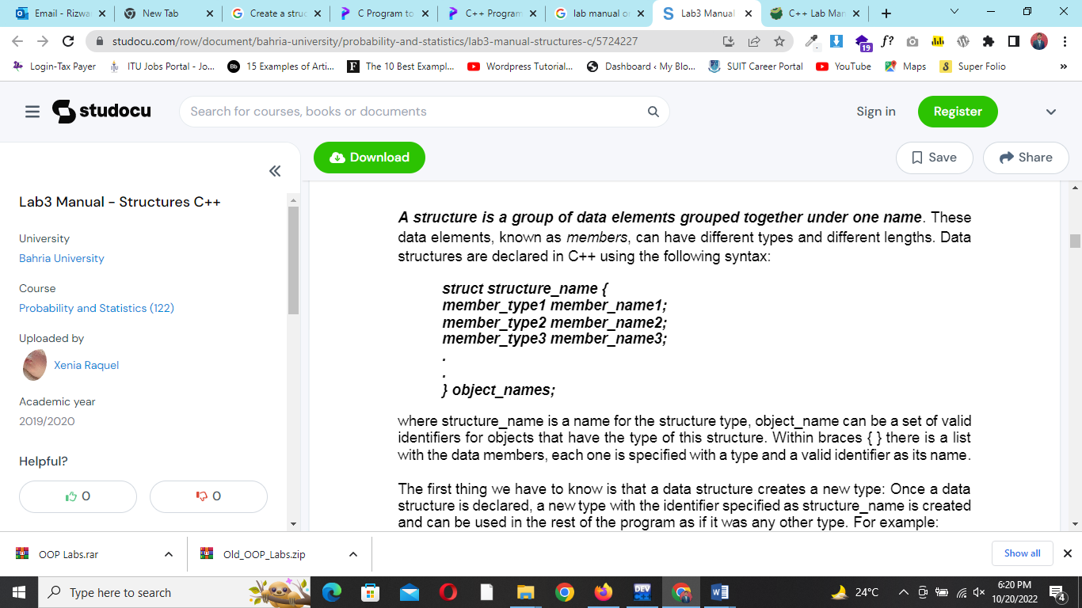

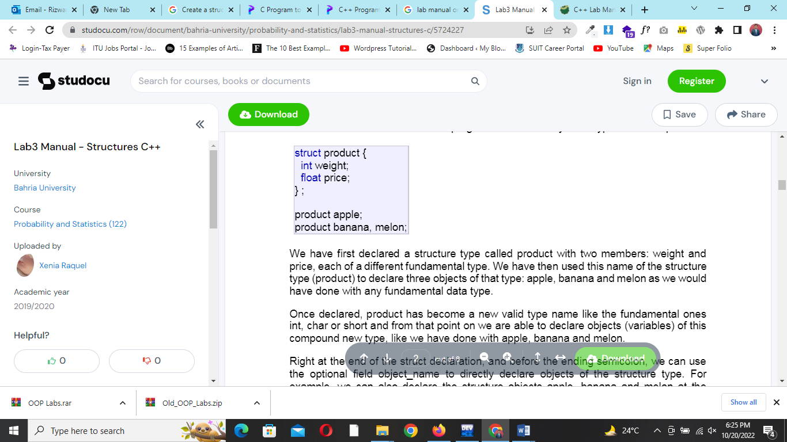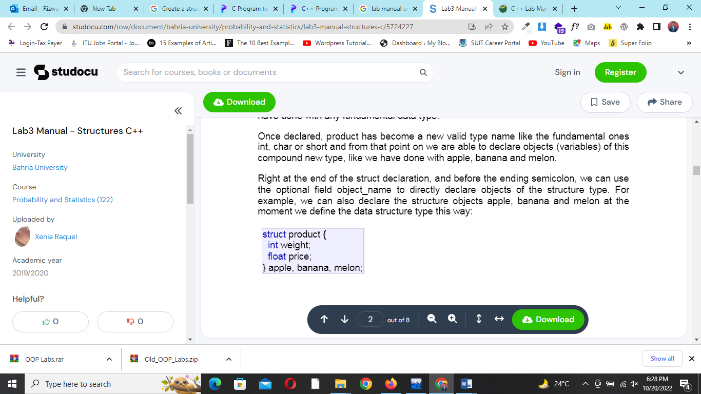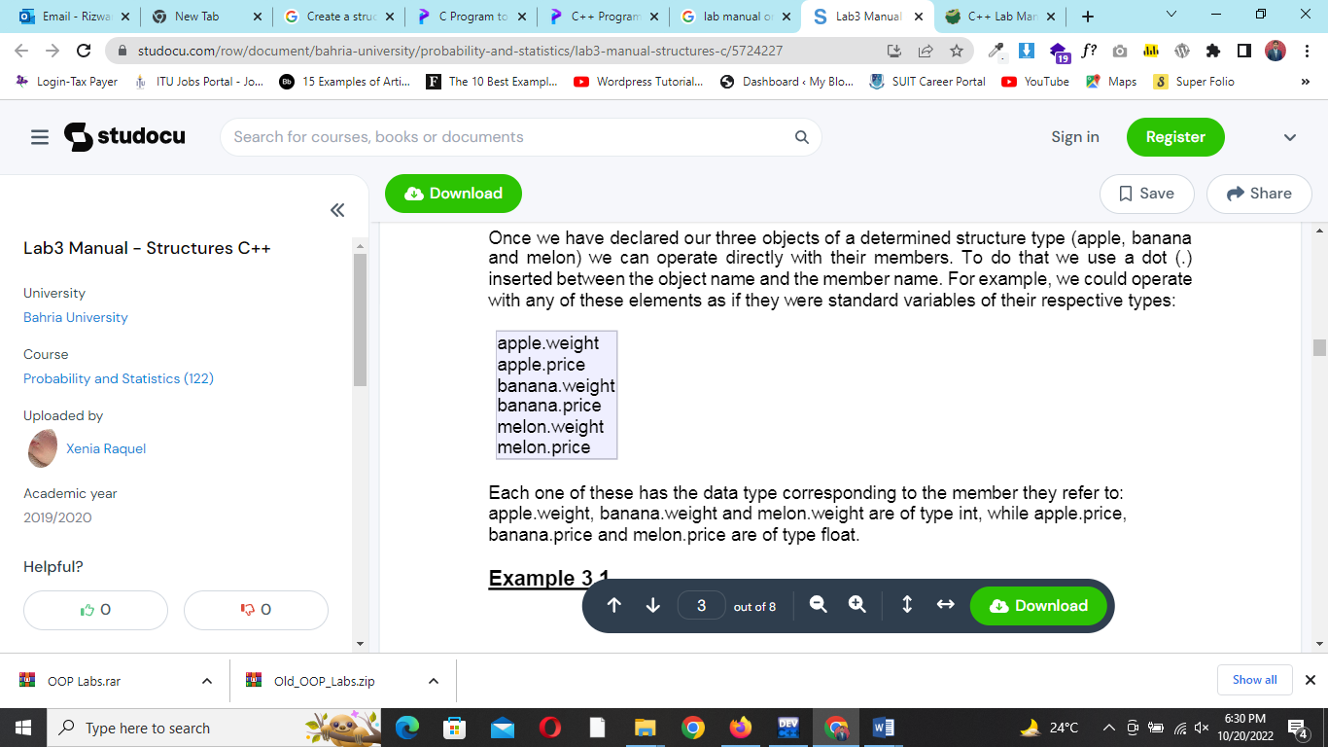

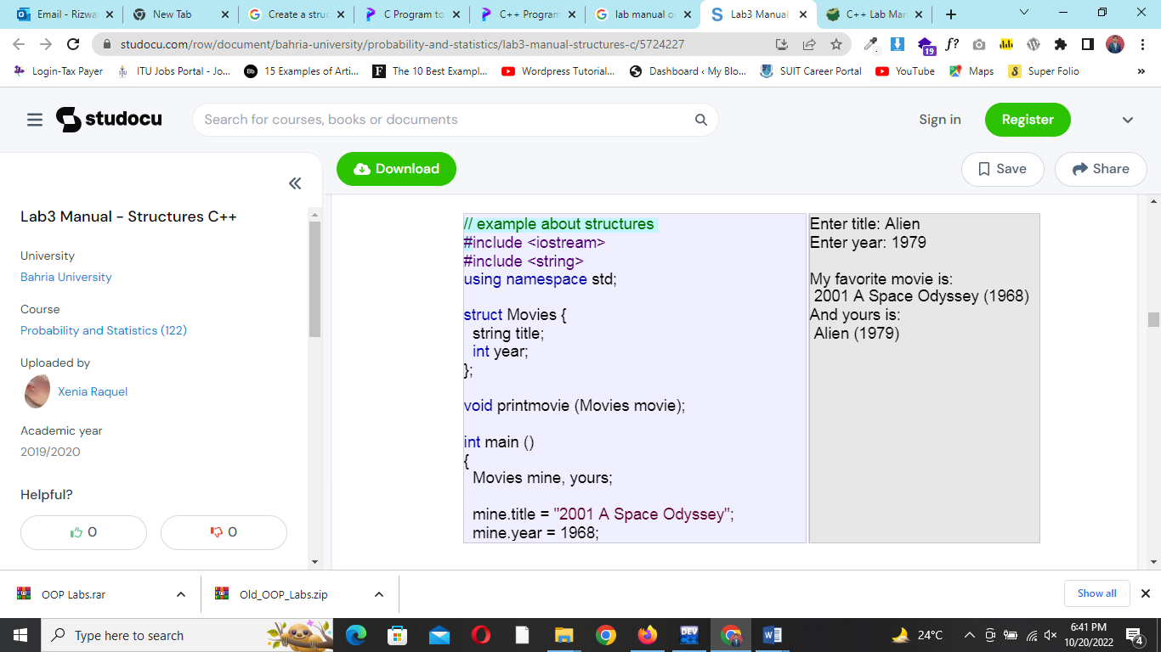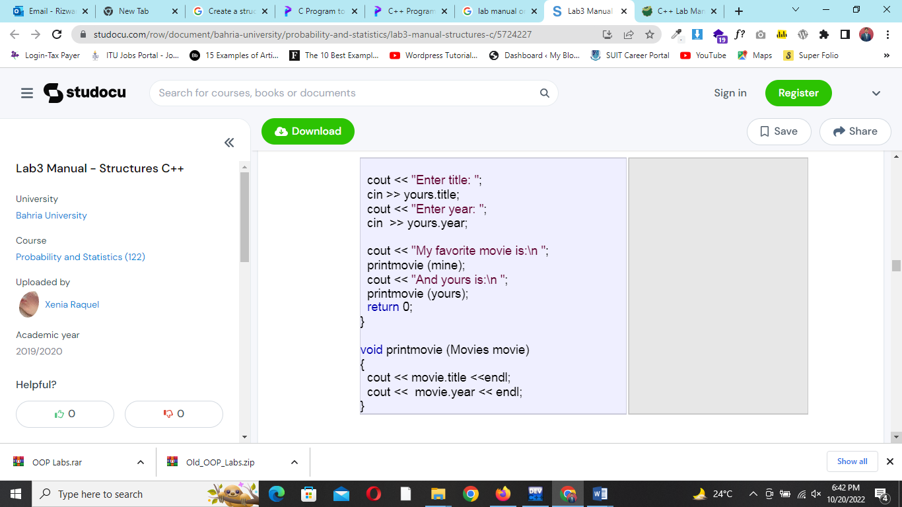Struct with functions

**Task 6:**

Create a struct called Student which has registration no, name, admission date and cgpa as member variables.

Write a function Input_Records for getting record of a student. Also write a function Display to print contents of the struct **student** on screen.